Day 2 – 17/05/2025

Q1. Explore GIT commands.

Commands used –

git log

git status

git show

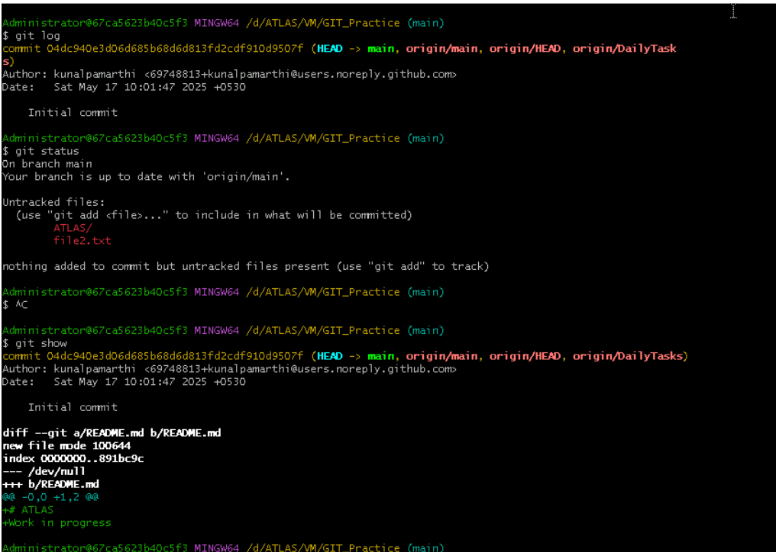

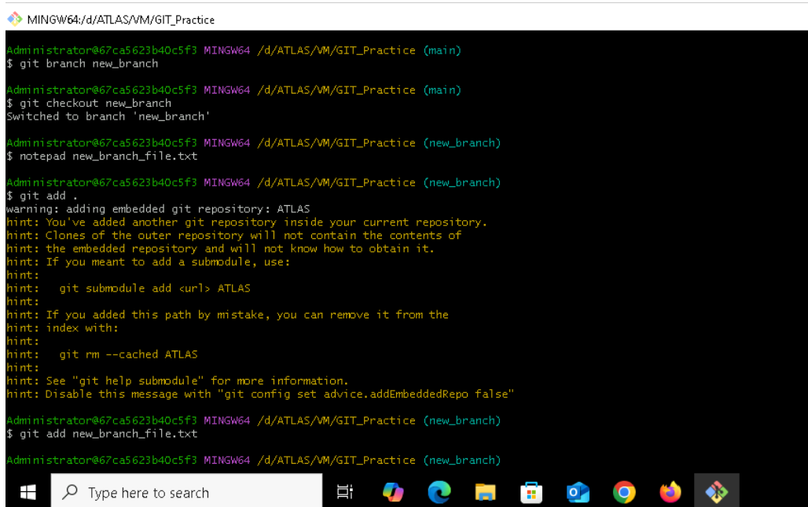

git branch new_branch

git checkout new_branch

notepad new_branch_file.txt

git add .

git add new_branch_file.txt

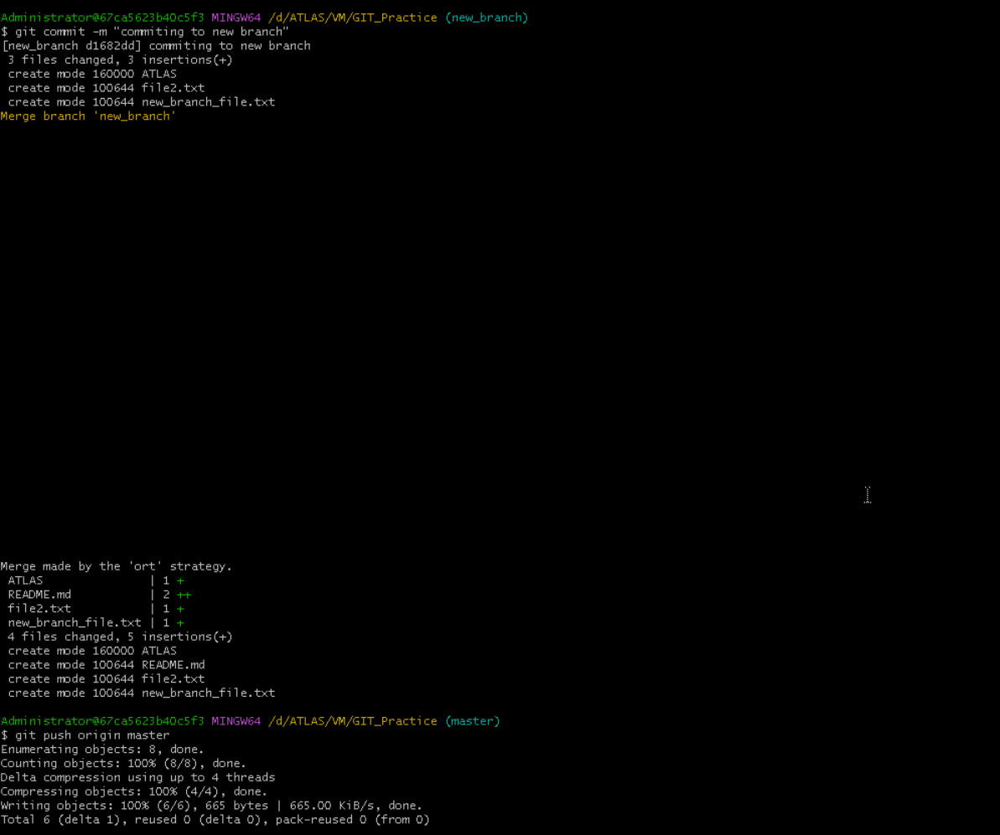

git commit -m “commiting to new branch”

git push origin master

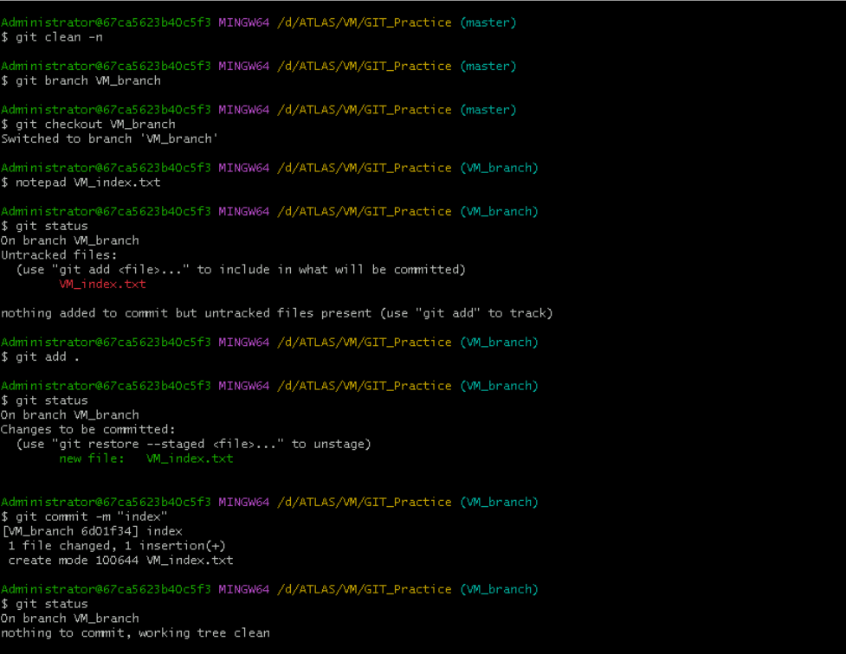

git clean -n

git branchVM_branch

git checkout VM_branch

notepad VM_index.txt

git status

git add .

git status

git commit -m “index”

git status

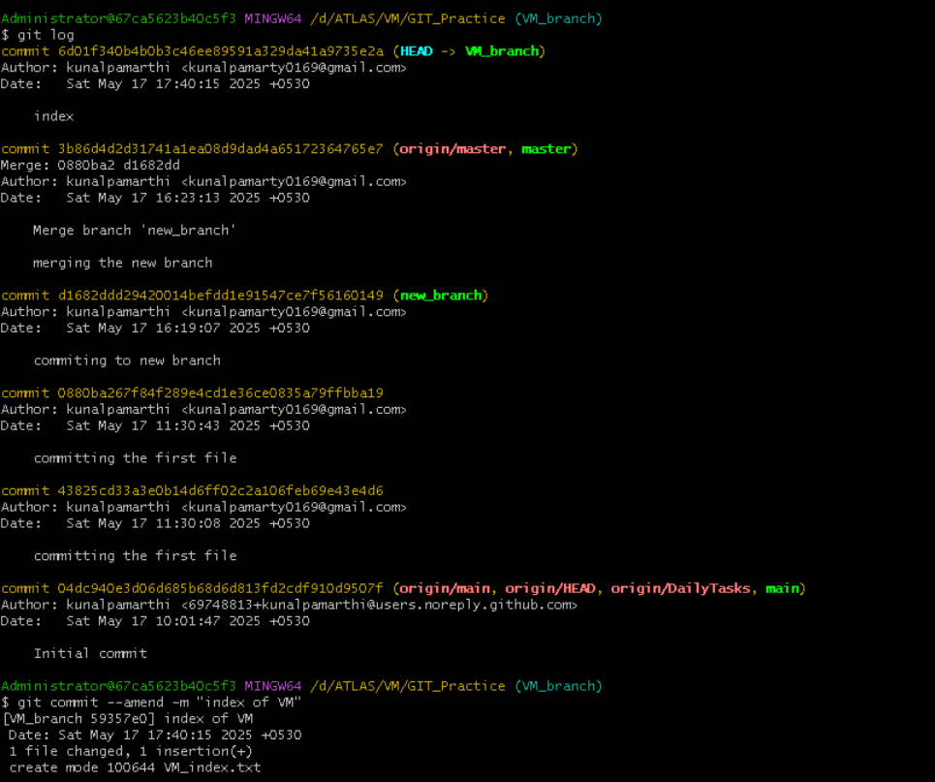

git log

git commit –amend -m “index of VM”

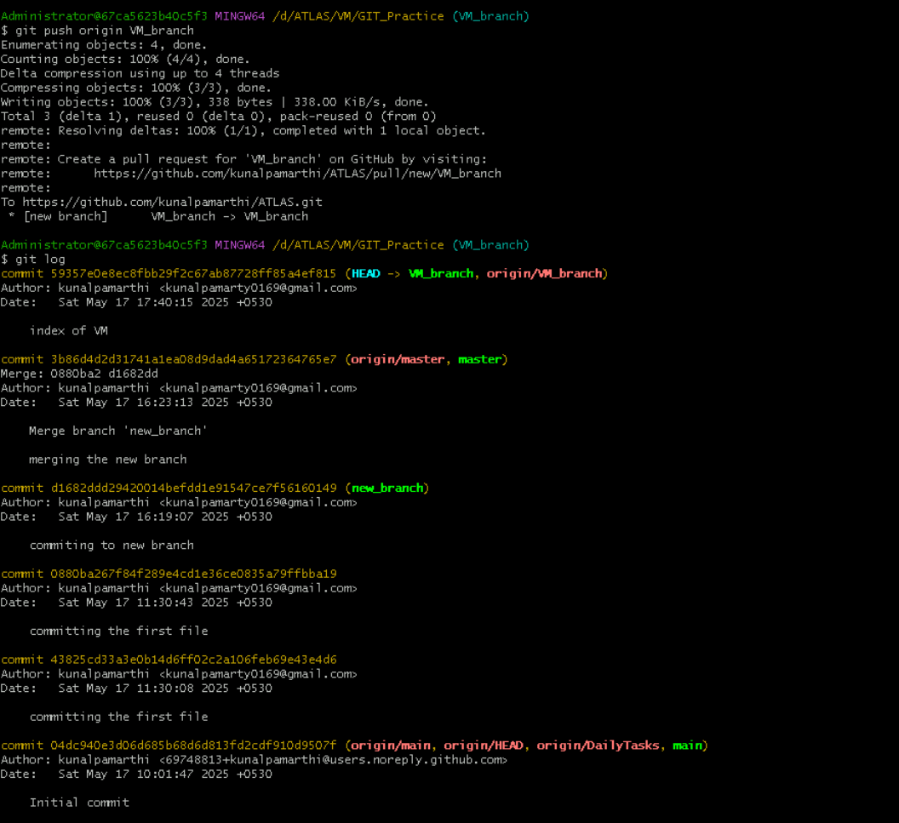

git push origin VM_branch

git log

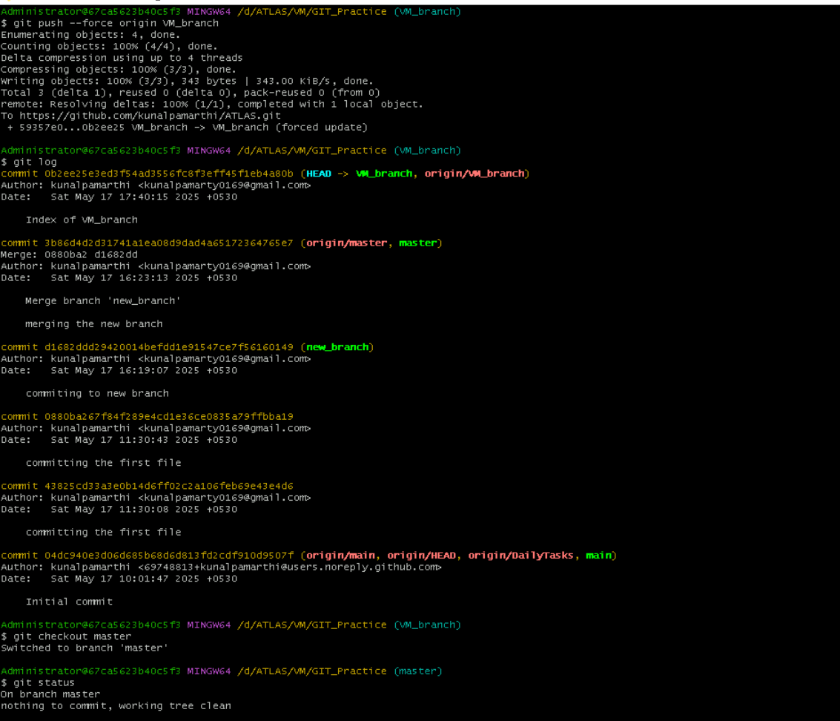

git push –force origin VM_branch

git checkout master

git status